This Pretest is to be completed as preparation for the Unit Test and will be graded as a section of this test.
Collaboration with classmates is permitted, but copying work is considered cheating and will result in a zero.
The use of class notes is not permitted to complete this assignment.

Directions: Apply derivative tests to the functions in order to sketch the graph of each.
$f(x)=\frac{x^{2}+\text{12}}{x+2}$ $f(x)=\frac{1}{x^{2}−1}$

$f(x)=\frac{4x}{x^{2}+1}$_______________ $f\text{''}(x)=$_______________

Critical Pts: x = _______ Critical Pts: x = _______

INT |  | INT
TV |  | TV
$$f '(\text{TV})$$ |  | $$f\text{''}(\text{TV})$$
Inc/Dec |  | CU/CD

Abs. Max. ________

Abs. Min. ________

Rel. Max. ________

Rel. Min. ________

P.O.I. ________

$f(x)=−4x^{1/2}+2x$ $[0, 4]$

$f(x)=\frac{4x}{x^{2}+1}$_______________ $f\text{''}(x)=$_______________

Critical Pts: x = _______ Critical Pts: x = _______

INT |  | INT
TV |  | TV
$$f '(\text{TV})$$ |  | $$f\text{''}(\text{TV})$$
Inc/Dec |  | CU/CD

Abs. Max. ________

Abs. Min. ________

Rel. Max. ________

Rel. Min. ________

P.O.I. ________

Directions: Sketch the graph of the function that exhibits the following characteristics.
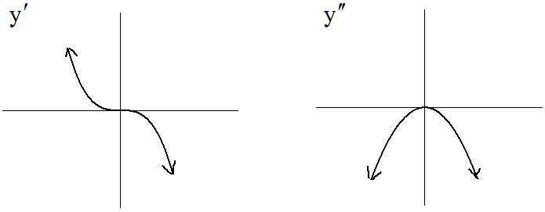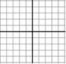

$f(0)=2$

$f(−3)=−2$

$f(3)=−2$

Directions: Identify all asymptotes and sketch the graphs of the functions.

$f(x)=\frac{x^{2}+\text{12}}{x+2}$ $f(x)=\frac{1}{x^{2}−1}$ $f(x)=\frac{4x}{x^{2}+1}$

H.A. @ ______ H.A. @ ______ H.A. @ ______

V.A. @ ______ V.A. @ ______ V.A. @ ______

S.A. @ ______ S.A. @ ______ S.A. @ ______

Abs. Max. ________

Abs. Min. ________

Rel. Max. ________

Rel. Min. ________

P.O.I. ________

